H.T No
Regulations:
A20

Sreenidhi Institute of Science and Technology
(An Autonomous Institution)
Code No: 8AC42 Date: 04-Feb-2025 (FN)

B.Tech I-Year I- Semester External Examination, Jan/Feb-2025 (Supplementary)
ELECTRICAL CIRCUITS AND NETWORK ANALYSIS (ECM)

Time: 3 Hours Max.Marks:70

Note: a) No additional answer sheets will be provided.
b) All sub-parts of a question must be answered at one place only, otherwise it will not be valued.
c) Missing data can be assumed suitably.
Bloom's Cognitive Levels of Learning (BCLL)

Remember | L1 | Apply | L3 | Evaluate | L5
Understand | L2 | Analyze | L4 | Create | L6

Part - A Max.Marks:20

Answer all QUESTIONS.

 |  | BCLL | CO(s) | Marks
1 | State KCL and KVL. | L1 | CO1 | [2M]
2 | Determine the RMS value of an AC Sinusoidal Waveform. | L2 | CO2 | [2M]
3 | State Faraday’s Laws of electromagnetic Induction. | L2 | CO3 | [2M]
4 | State Maximum Power transfer Theorem. | L2 | CO4 | [2M]
5 | Define Port and Two-port network. | L1 | CO5 | [2M]
6 | What is meant by Transient Analysis. | L1 | CO6 | [2M]
7 | Explain about a Supermesh. | L2 | CO1 | [2M]
8 | Explain about dot convention. | L2 | CO4 | [2M]
9 | Sketch the DC response of RC circuit and response curve. | L1 | CO6 | [2M]
10 | Explain about a Super Node. | L1 | CO2 | [2M]

Part – B Max.Marks:50
ANSWER ANY FIVE QUESTIONS. EACH QUESTION CARRIES 10 MARKS.

 |  |  | BCLL | CO(s) | Marks
11. | a) | Use Mesh Analysis to obtain i_{1,} i_{2,} i₃ for the circuit shown in Figure  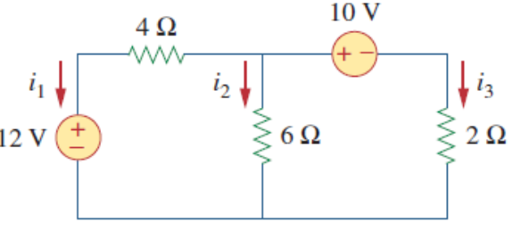 | L3 | CO1 | [5M]
 | b) | Find the equivalent resistance between the terminals A and B of the network shown in Figure. by using star/delta transformation.  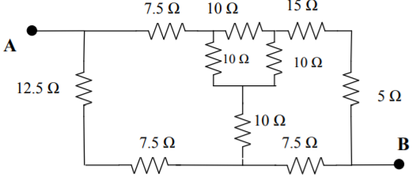 | L3 | CO1 | [5M]
12. | a) | A coil of resistance 40 Ω and inductance 0·75 H forms part of series circuit for which the resonant frequency is 55 Hz. If the supply is 250 V, 50 Hz, find (i) line current, (ii) power factor of total circuit and coil, (iii) voltage across the coil. | L4 | CO2 | [5M]
 | b) | A series RLC circuit with R=10 Ohm, L=0.1 H and C=50 µF has an applied voltage V=50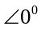 with a variable frequency .Find the resonant frequency, the value of frequency at which maximum voltage occurs across the inductor and the value of frequency at which maximum voltage occurs across the capacitor. | L3 | CO2 | [5M]
13. | a) | Bring out an analogy between magnetic circuits and electric circuits. | L2 | CO3 | [5M]
 | b) | A ring shaped electromagnet has an air gap of 6 mm and 20 cm² in area, the mean length of the core being 50 cm and its cross section is 10 cm². Calculate the ampere-turns required to produce a flux density of 0.5 Wb/m² in the gap. Assume the permeability of iron is 1800 | L2 | CO3 | [5M]
14. | a) | Find the Norton equivalent circuit for the circuit shown in the figure at terminals a-b.  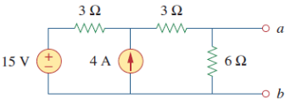 | L4 | CO4 | [5M]
 | b) | For the circuit shown below, use the superposition theorem to find the current i  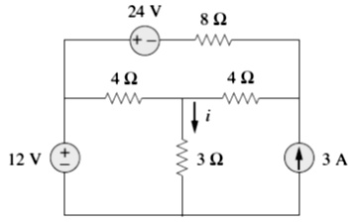 | L4 | CO4 | [5M]
15. | a) | Determine the h parameters for the circuit shown below.  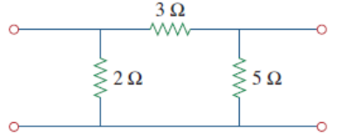 | L3 | CO5 | [5M]
 | b) | Express the ABCD parameters of a Two port network in terms of Z parameters. | L2 | CO5 | [5M]
16. | a) | A series R-L circuit has R = 25 Ω and L = 5H. A DC voltage of 100 V is applied at t = 0. Find: (a) The equations for charging current, voltage across R and L. (b) The current in the circuit 0.5 sec later. (c) The time at which the drop across R and L are same. | L3 | CO6 | [5M]
 | b) | A series R-C circuit with R=10 ohms and C= 2F has a sinusoidal voltage source 200 sin(500t+Փ) applied at time when Փ=0. Find the expression for current. | L3 | CO6 | [5M]
17. | a) | Derive the expression for star to delta transformation for a given network. | L2 | CO1 | [4M]
 | b) | Explain quality factor in Resonating Circuits. | L2 | CO2 | [3M]
 | c) | What is meant by Self and Mutual Inductance. | L2 | CO3 | [3M]
18. | a) | Find Thevenin’s Equivalent circuit at terminals a-b.  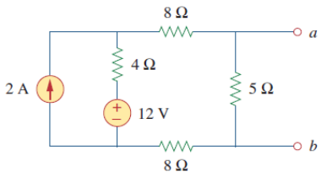 | L2 | CO4 | [4M]
 | b) | Derive the symmetry for ABCD parameters. | L2 | CO5 | [3M]
 | c) | Derive the expression for i(t) and voltage across capacitor V_{c}(t) for series RC circuit with D.C voltage applied to it at t=0 | L2 | CO6 | [3M]

-- 00 -- 00 –

